Sprint 1 - Personal portfolio

Jayden Dao – n10003665

Due Date: 4 May, 2018

**Business Plan Model and Notation**

Have produced Business plan model and notation constructs the process of the client. This goes through the process of client navigating to the site and going through registration process which would then be able to learn an instrument. This process utilizes logins and registrations from students, teachers and admins. The site would help students and parents decide on the course that most suits them. The BPMN show how each process would be conducted to create a natural flow of the website structure.

This allowed the team to better understand usages of the website from another perspective. It would help members of the team layout the sites structure for a more user-friendly experience.

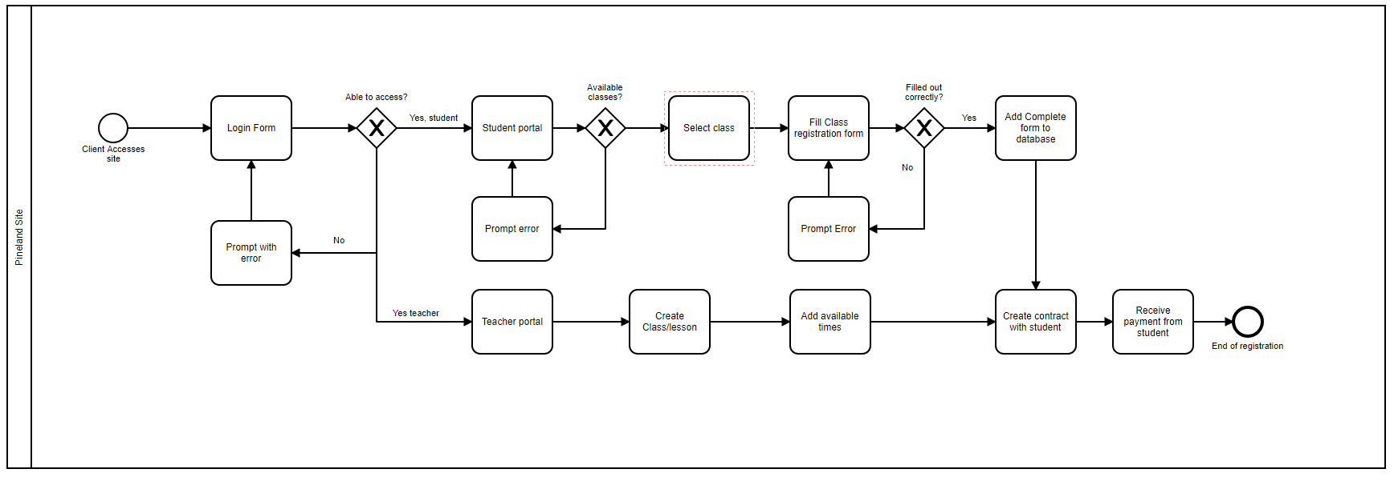

**Colour scheme**

The Colour scheme is used to unify the website design to make the overall site more user friendly. This consists of matching colours alongside each other. Also, have indicated the text font choice and look of the button with matching colours with each other. This was to match colours with.

The process of finding and comparing colour choices took a little time. But one the decision was lock in, the it was a matter of adapting these colours into the site. This would allow the CSS to be create for a integrated style. This was useful for team members working on the website as each page, text and button followed a similar colour scheme. It allowed all the pages follow a similar style sheet which would increase work flow.

The colour scheme structure is shown below

|  |  |  |  |
| --- | --- | --- | --- |
| #424242 | #95c079 | #cde1cc | #eff9f4 |
|  |  |  |  |

**Logo**

A number of attempts and redesigns have been make to the logo with a number of sketches and mock up designs to best integrate the name and theme into the logo. This consists creating multiple examples designs to show team members who would provide feedback. Logo was created used photoshop and silhouette images to integrate both music and pine trees. The target audience was directed towards a sophisticated demographic while also maintain transparency for a wide range of students.

This allowed the team to better understand the theme of Pineland Music school as it has been created to imply a profession look. The logo has been created with multiple variances to fit any area of the website. Each layer was saved individually so changes can be easily made in the future when needed.

|  |  |  |
| --- | --- | --- |
| Planning Stage | Design Concept | Final Logo |

**HTML pages**

I have coded the student view available classes, Teachers view booked classes and admin creates teacher account pages. This is comprised with bootstrap formatting along side html code. Viewing classes and viewing booked classes comprised of table with an ‘#ID’ to help fields to present information stored from the database.

This helped the team build the database and attach it to the website. Having this functionality would allow members working on the database able to test the functionality and user experience.

This example shows the coding for the Teacher registration.

|  |
| --- |
| <?php  $basename = 'Teacher Registration';  $form = 'teacherregform';  require_once("../../../resources/config.php");  require_once(TEMPLATES_PATH . "/header.php");  require_once(TEMPLATES_PATH . "/banner.php");  require_once(LIBRARIES_PATH . "/registerfunc.php");  require_once(TEMPLATES_PATH . $_SESSION["user"][3]);  ?>  <div class="container">  <form action="<?php echo htmlspecialchars($_SERVER["PHP_SELF"]);?>" name="regform" method="POST" id="regform">  <div class="col-md-6">  <div class="panel">  <div class="panel-heading">  <h3 class="panel-title">Teachers Information</h3>  </div>  <div class="panel-body" >  <table class="table">  <tbody>  <tr>  <td id="cellleft">First Name :</td>  <td id="cellright"><input required type="text" name="firstname" placeholder="Given Names"></td>  </tr>  <tr>  <td id="cellleft">Last Name :</td>  <td id="cellright"><input required type="text" placeholder="Family Name" name="lastname"></td>  </tr>  <tr>  <td id="cellleft">Username :</td>  <td id="cellright"> <input required type="username" name="username" placeholder="Username"></td>  </tr>  <tr>  <td id="cellleft">Password :</td>  <td id="cellright"> <input required type="password" name="password" placeholder="Password"></td>  </tr>  <tr>  <td id="cellleft">Date of Birth :<br><p class="text-muted"> Under 18 will be required</br>to give parent information<p></td>  <td id="cellright"><input required type="date" class="bday" name="dob"></td>  </tr>  <tr>  <td id="cellleft">Address :</td>  <td id="cellright"><textarea required rows="4" cols="30" placeholder="" name="address"></textarea></td>  </tr>  <tr>  <td id="cellleft">Gender :</td>  <td id="cellright"><input type="radio" name="gender" value="male"> Male<br>  <input type="radio" name="gender" value="female"> Female<br>  <input type="radio" name="gender" value="other"> Other </td>  </tr>  <tr>  <td id="cellleft">Phone Number :</td>  <td id="cellright"><input required type="tel" name="mobphone" placeholder="Phone Number"></td>  </tr>  <tr>  <td id="cellleft">Email :</td>  <td id="cellright"><input required type="email" name="email" placeholder="Email"></td>  </tr>  <tr>  <td id="cellleft">Language :</td>  <td id="cellright"> <select>  <!-- Will change to list all available in DB !-->  <option value="" disabled selected>Select</option>  <option value="english">English</option>  <option value="Spanish">Spanish</option>  <option value="french">French</option>  <option value="mandarin">Mandarin</option>  <option value="arabic">Arabic</option>  </select> </td>  </tr>  <tr>  <td id="cellleft">Instruments :</td>  <td id="cellright"> <select>  <!-- Will change to list all available in DB !-->  <option value="" disabled selected>Select</option>  <option value="saxophone">Saxophone</option>  <option value="trumpet">Trumpet</option>  <option value="marrccas">Marrccas</option>  <option value="triangle">Triangle</option>  </select> </td>  </tr>  </tbody>  </table>  <input type="submit" class="btn btn-primary" value="submit" form="regform">  </div>  </div>  </div>  <div class="col-md-6">  <div class="panel">  <div class="panel-body" style="padding-top: 75px">  <img src="img/logo.jpg" height=100% width=100% style="border: 2px solid black">  </div>  </div>  </div>  </form>  </div>  <?php  require_once(TEMPLATES_PATH . "/footer.php");  ?> |

**Meeting times**

Meeting times indicate the overall progress and helps team keep track of tasks completed and upcoming project. This is a tracker of all the team meetings with content which was discussed while together.

This helps the team keep track of the overall projects direction and a performance indicator. I also identify areas which could be improved and make sure all areas of the case study is complete.

|  |  |  |
| --- | --- | --- |
| **Date** | **Meetings** | **Content Coved** |
| 2 May | Week 8 tut | Sprint 1 personal portfolios |
| 18 April | Week 7 tut | Worked on sprint 1 releases. |
| 28 March | Week 6 tut | Finalize submission and discuss work over the holiday |
| 24 March | Meeting for 3 hours | Refine user stories and release & sprint planning before submission |
| 21 March | Week 5 tut | Improve user stories and discussed sprint planning |
| 16 March | Meeting for 2 hours | Discussed component to the sprint planning |
| 14 March | Week 4 tut | Layout user stories and checked all project case studies were included |
| 7 March | Week 3 tut | Dissected and understand Project Case study |
| 28 Feb | Week 2 tut | Created and accepted team agreement |
| 21 Feb | Week 1 tut | Understand each other’s strength and weaknesses and established a name, ‘Tooting Trumpets’ |